**Database Project (100 points – 10 points per question)**

Use the **Database Project worksheet** that you download from our course to answer the following questions. When completed, you will upload the file in MyPHSC.

1. For the three tables, identify the Primary Keys and Composite primary keys.

Production.Product

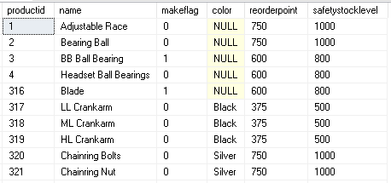

Production.ProductInventory

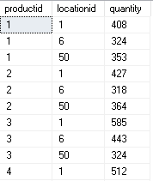

Production.Location

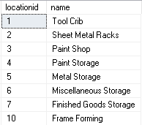

1. For the tables in question #1, what is the name of the the linking table?
2. For the two tables, identify the Primary Keys, Composite primary keys and Foreign Keys.

Sales.SalesPerson

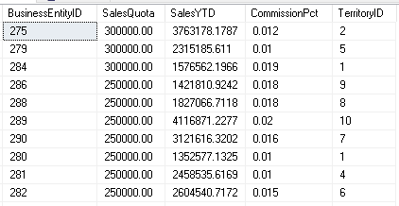

Sales.SalesTerritory

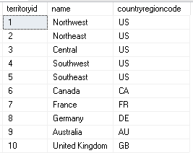

1. For the two tables, identify the Primary Keys, Composite primary keys and Foreign Keys. This is an example of a **one-to-one relationship,** since the business rule states you have one password to get in all systems.

Person.Person

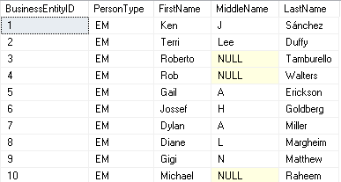

Person.Password

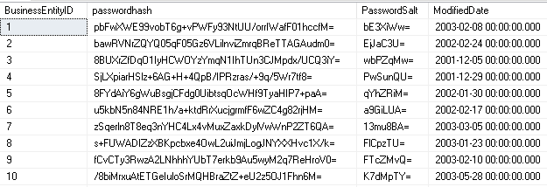

5. For the three tables, identify the Primary Keys, Composite primary keys and Foreign Keys.

Sales.SalesPerson



Sales.CreditCard

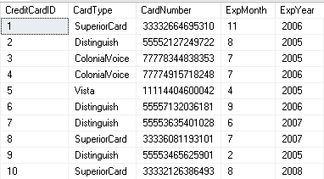

Sales.PesonCreditCard

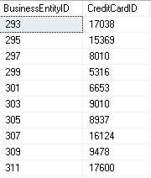

6. For the three tables, identify the Primary Keys, Composite primary keys and Foreign Keys.

Production.Product



Production.ScrapReason

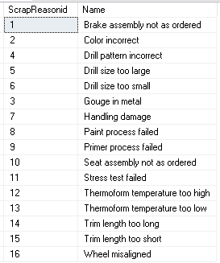

Production.WorkOrder – **Notice when I look at the WorkOrderID, there is only one product for each WorkOrder. So WorkOrderID is enough to uniquely identify a row in the table, so it’s the primary key.**

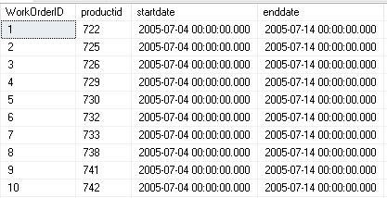

7. For the three tables, identify the Primary Keys, Composite primary keys and Foreign Keys.

Production.Product



Sales.SpecialOfferProduct

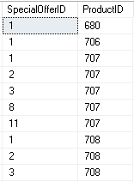

Sales.SpecialOffer

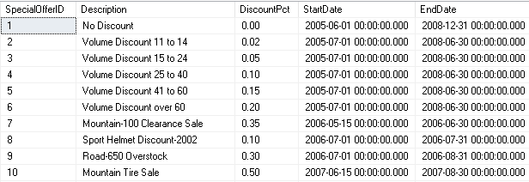

8. What is the name of the linking table from question # 7?

9. For the two tables, identify the Primary Keys, Composite primary keys and Foreign Keys.

Recipes.Recipes



Recipes.Recipe_Classes

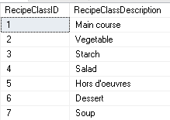

10. For the three tables, identify the Primary Keys, Composite primary keys and Foreign Keys.

School.Class_Rooms

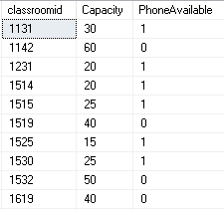

School.Classes

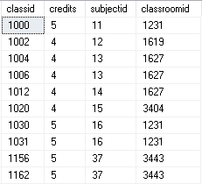

School.Subjects

